Technical Document
IVF Trigger Day Prediction – End-to-End ML Pipeline

1. Project Overview
This project implements an end-to-end, production-ready Machine Learning pipeline to predict the IVF Trigger Day based on patient clinical and hormonal data. The system automates data ingestion, validation, storage, feature engineering, model training, and deployment using modern data engineering and MLOps tools.
Objective:
- Predict the optimal IVF trigger day with high reliability
- Ensure data quality and reproducibility
- Enable scalable, automated ML workflows
Key Technologies:
- Python, Pandas, NumPy
- Great Expectations (Data Validation)
- PostgreSQL (Database)
- Scikit-learn (ML Models)
- MLflow (Experiment Tracking)
- Apache Airflow (Orchestration)
- FastAPI (Model Deployment)

2. System Architecture
High-Level Flow
Raw CSV Data → Ingestion → Validation → Database → Feature Engineering → Clustering → Model Training → MLflow Tracking → Saved Model → FastAPI API
Component Roles:
- Airflow: Orchestrates the entire pipeline
- Great Expectations: Ensures schema and distribution integrity
- PostgreSQL: Stores raw and processed datasets
- MLflow: Tracks experiments and models
- FastAPI: Serves predictions via REST API

3. Project Folder Structure
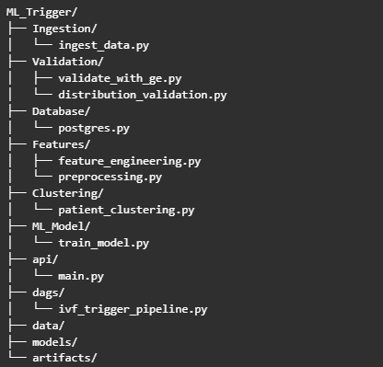

4. Data Ingestion Module
The ingestion module reads the IVF trigger dataset from a CSV file and converts it into a pandas DataFrame. This serves as the entry point for the pipeline and ensures consistency across runs.
Responsibilities:
- Load raw CSV data
- Basic sanity checks
- Pass data downstream

5. Data Validation
5.1 Schema Validation (Great Expectations)
The pipeline validates:
- Column presence
- Null values
- Acceptable ranges for age, AMH, hormone levels
- Valid target values
This ensures only high-quality data proceeds further.
5.2 Distribution Validation
Advanced validation checks ensure:
- Mean drift within ±20%
- Standard deviation within acceptable bounds
- Cluster ID range consistency
This protects the model from data drift and silent failures.

6. Database Layer (PostgreSQL)
The database stores:
- Raw ingested data
- Preprocessed training data
- Preprocessed testing data
Why PostgreSQL?
- Reliability
- ACID compliance
- Easy integration with Python

7. Feature Engineering
Feature engineering incorporates both clinical and ML insights.
Key Features:
- Age Groups
- AMH Indicators
- Hormone Ratios
- Day Zones
- Missing Value Flags
These features improve model performance and interpretability.

8. Model Training & Experiment Tracking
Modeling Strategy
- Train/Test Split: 80/20
- Patient segmentation using KMeans clustering
- Random Forest classifier for prediction

MLflow Tracking
- Parameters
- Metrics
- Model artifacts
Ensures full reproducibility and experiment comparison.

9. Workflow Orchestration (Apache Airflow)
The Airflow DAG automates the pipeline using a linear task structure:
- Data Ingestion
- Data Validation
- Database Load
- Model Training
DAG Characteristics:
- Manual trigger
- Retry enabled
- Fail-fast execution
- Single active run

10. Model Deployment (FastAPI)
The trained model is exposed via a REST API.
Features:
- /predict endpoint
- JSON-based input/output
- Consistent preprocessing
- Lightweight and scalable

11. Conclusion
This project demonstrates a complete, production-grade ML pipeline integrating data engineering, validation, orchestration, and deployment best practices. It is suitable for real-world healthcare ML applications and showcases strong MLOps capabilities.

Author: Jeshwanth

